Supplementary data

Wei Zhang, Stefan Kraft and Jeffrey S. Moore*
Roger Adams Laboratory, Department of Chemistry and Materials Science & Engineering, University of Illinois at Urbana-Champaign, Urbana, IL 61801, USA.
Fax: 1-217-244-8068; Tel: 1-217-244-4024; E-mail: js-moore@uiuc.edu

Molybdenum(VI) methylidyne 5: ¹H NMR (d₈-toluene, 500 MHz): δ 6.63 (3H, s), 5.97 (6H, s), 5.59 (1H, d), 2.08 (18H, s), 1.46 (27H, s); ¹³C NMR (d₈-toluene, 125 MHz): δ 287.5, 150.5, 137.1, 130.5, 127.7, 60.0, 33.9, 21.4. The spectroscopic data are in agreement with that reported in the literature.ª

Molybdenum(VI) ethylidyne 6: ¹H NMR (d₈-THF, 500 MHz): δ 6.70 (3H, s), 5.80 (6H, s), 3.11 (3H, s), 2.10 (18H, s), 1.26 (27H, s); ¹³C NMR (d₈-THF, 125 MHz): δ 294.4, 151.3, 137.6, 130.7, 128.0, 61.6, 37.6, 34.1, 21.9; MS (EI): m/z (%): 653.3 (1), 446.2 (87), 162.1 (47), 121.1 (100), 91.1 (54); HR-MS (EI) (C₃₈H₅₇MoN₃): calcd 653.3607, found 653.3599.

ª J. B. Greco, J. C. Peters, T. A. Baker, W. M. Davis, C. C. Cummins and G. Wu, J. Am. Chem. Soc. 2001, 123, 5003.

Methylidyne-¹H

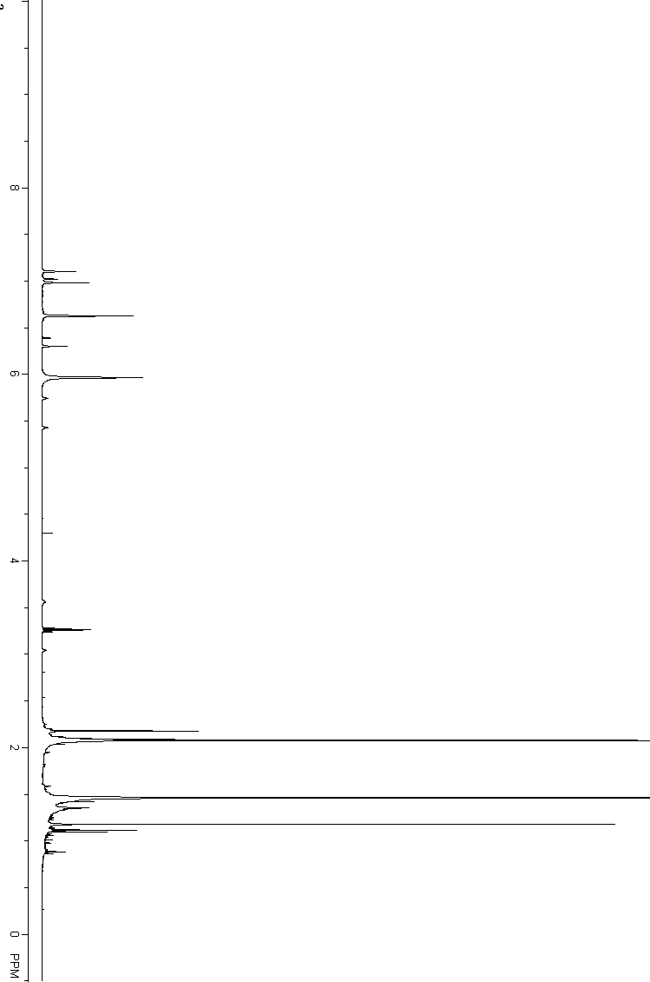
Methylidyne-¹³C
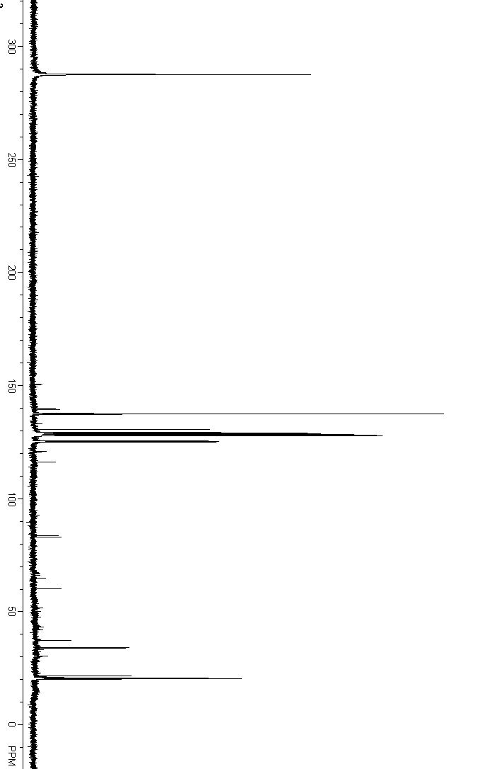
Ethylidyne-¹H
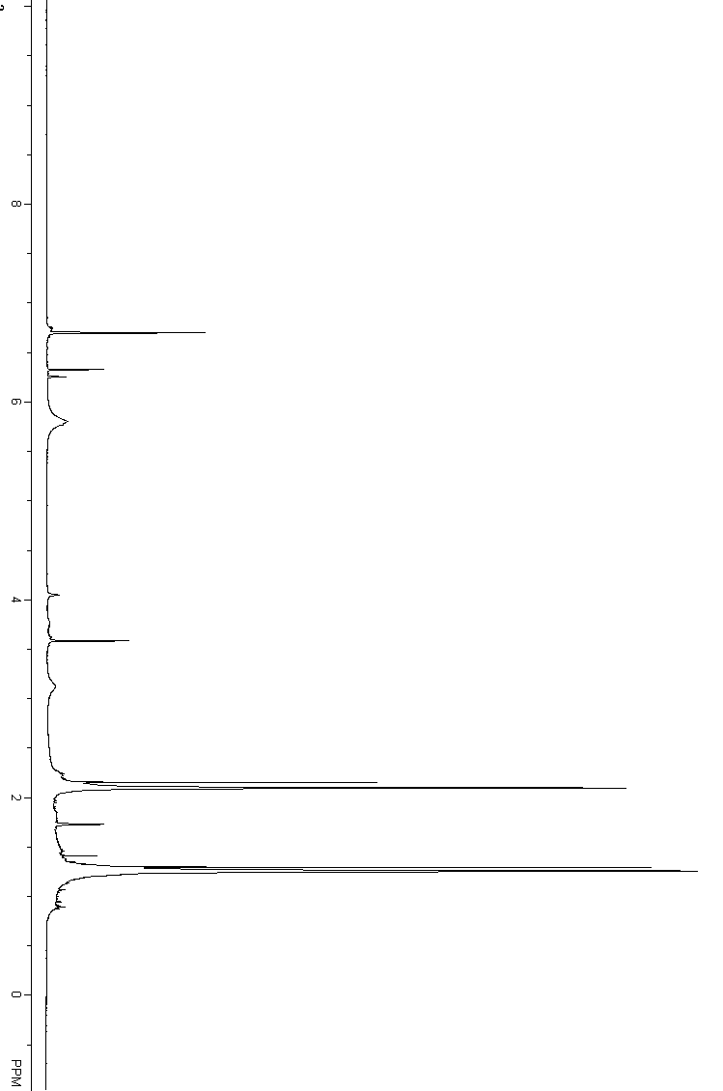
Ethylidyne-¹³C
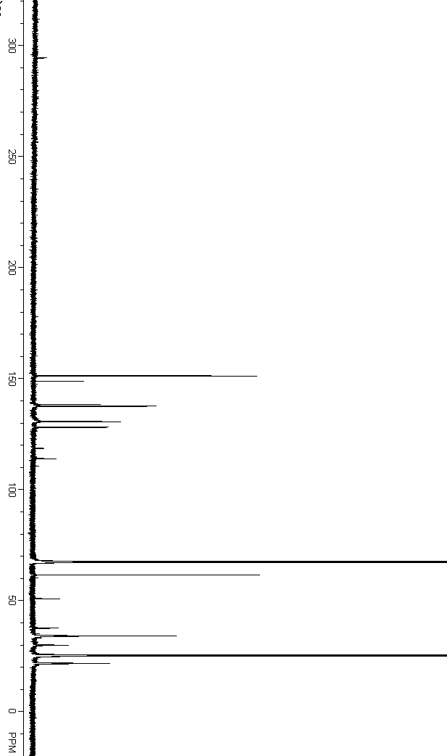
Propylidyne-¹H
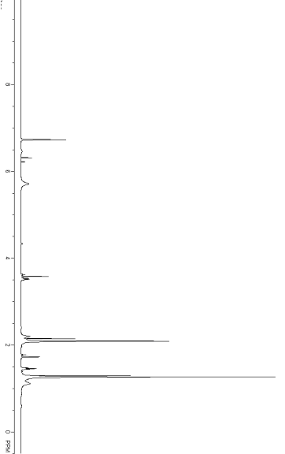
Propylidyne-¹³C
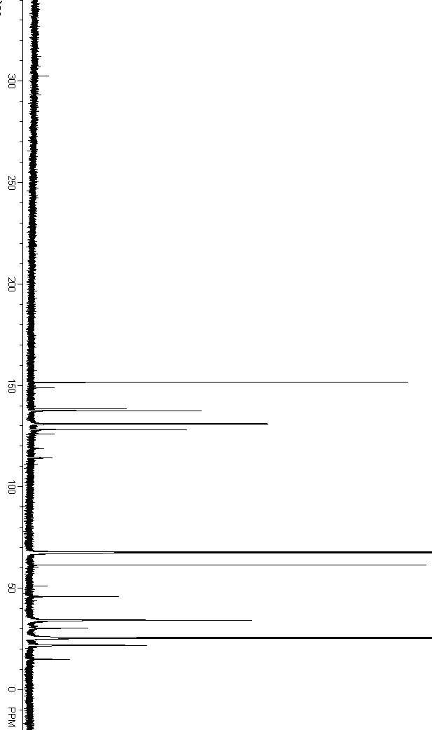
Table 1. Crystal data and structure refinement for p91tas (Propylidyne 7).
Identification code p91tas
Empirical formula C39 H59 Mo N3
Formula weight 665.83
Temperature 193(2) K
Wavelength 0.71073 Å
Crystal system Monoclinic
Space group P 21/c
Unit cell dimensions a = 19.144(10) Å α= 90°.
b = 10.513(6) Å β= 104.075(9)°.
c = 19.324(11) Å γ = 90°.
Volume 3772(4) Å3
Z 4
Density (calculated) 1.172 Mg/m3
Absorption coefficient 0.376 mm-1
F(000) 1424
Crystal size 0.59 x 0.38 x 0.05 mm3
Theta range for data collection 2.17 to 25.36°.
Index ranges -23<=h<=23, -12<=k<=12, -23<=l<=23
Reflections collected 39471
Independent reflections 6919 [R(int) = 0.0446]
Completeness to theta = 25.36° 99.9 %
Absorption correction Integration
Max. and min. transmission 0.9809 and 0.7692
Refinement method Full-matrix least-squares on F2
Data / restraints / parameters 6919 / 0 / 404
Goodness-of-fit on F2 1.037
Final R indices [I>2sigma(I)] R1 = 0.0327, wR2 = 0.0792
R indices (all data) R1 = 0.0453, wR2 = 0.0844
Largest diff. peak and hole 0.459 and -0.298 e.Å-3
Table 2. Atomic coordinates ( x 104) and equivalent isotropic displacement parameters (Å2x 103)
for p91tas. U(eq) is defined as one third of the trace of the orthogonalized Uij tensor.
________________________________________________________________________________
x y z U(eq)
________________________________________________________________________________
C(1) 2276(1) 11323(2) 3311(1) 35(1)
C(2) 2025(1) 12123(2) 2730(1) 38(1)
C(3) 1312(2) 12560(3) 2562(1) 46(1)
C(4) 858(1) 12180(3) 2980(1) 46(1)
C(5) 1092(1) 11365(3) 3561(1) 42(1)
C(6) 1802(1) 10956(2) 3722(1) 37(1)
C(7) 1048(2) 13420(3) 1926(2) 66(1)
C(8) 577(2) 10909(3) 3991(2) 55(1)
C(9) 3529(1) 11503(3) 4080(1) 43(1)
C(10) 3563(2) 10785(3) 4773(1) 59(1)
C(11) 4270(2) 11515(3) 3920(2) 54(1)
C(12) 3303(2) 12871(3) 4165(2) 69(1)
C(13) 3072(1) 10459(2) 1650(1) 34(1)
C(14) 3360(1) 11680(2) 1782(1) 37(1)
C(15) 3032(1) 12725(3) 1394(1) 42(1)
C(16) 2414(2) 12515(3) 848(1) 45(1)
C(17) 2122(1) 11311(3) 699(1) 45(1)
C(18) 2448(1) 10284(3) 1109(1) 37(1)
C(19) 3324(2) 14048(3) 1577(2) 55(1)
C(20) 1462(2) 11111(3) 98(2) 64(1)
C(21) 4013(1) 8764(3) 1815(1) 40(1)
C(22) 4728(2) 9343(3) 2221(2) 67(1)
C(23) 4004(2) 7355(3) 1958(2) 66(1)
C(24) 3933(2) 8981(4) 1020(2) 67(1)
C(25) 1766(1) 8114(2) 2253(1) 34(1)
C(26) 1813(1) 7257(2) 1714(1) 40(1)
C(27) 1327(2) 7302(3) 1050(1) 45(1)
C(28) 800(1) 8235(3) 928(1) 47(1)
C(29) 742(1) 9111(3) 1445(2) 44(1)
C(30) 1228(1) 9033(2) 2118(1) 36(1)
C(31) 1367(2) 6347(3) 479(2) 66(1)
C(32) 153(2) 10093(3) 1317(2) 65(1)
C(33) 2133(2) 7025(3) 3427(2) 48(1)
C(34) 2521(2) 7348(3) 4191(1) 56(1)
C(35) 1331(2) 6985(5) 3398(2) 102(2)
C(36) 2399(3) 5755(3) 3233(2) 97(2)
C(37) 3805(1) 8509(3) 3536(1) 41(1)
C(38) 4444(2) 7935(4) 4050(2) 75(1)
C(39) 4497(2) 6556(4) 4105(2) 109(2)
Mo(1) 3078(1) 9240(1) 2960(1) 28(1)
N(1) 3011(1) 10857(2) 3469(1) 33(1)
N(2) 3409(1) 9380(2) 2066(1) 33(1)
N(3) 2273(1) 8058(2) 2946(1) 32(1)
________________________________________________________________________________
Table 3. Bond lengths [Å] and angles [°] for p91tas.
_____________________________________________________
C(1)-C(2) 1.392(3)
C(1)-C(6) 1.397(3)
C(1)-N(1) 1.450(3)
C(2)-C(3) 1.401(4)
C(2)-H(2) 0.9500
C(3)-C(4) 1.382(4)
C(3)-C(7) 1.510(4)
C(4)-C(5) 1.397(4)
C(4)-H(4) 0.9500
C(5)-C(6) 1.387(4)
C(5)-C(8) 1.513(4)
C(6)-H(6) 0.9500
C(7)-H(7A) 0.9800
C(7)-H(7B) 0.9800
C(7)-H(7C) 0.9800
C(8)-H(8A) 0.9800
C(8)-H(8B) 0.9800
C(8)-H(8C) 0.9800
C(9)-N(1) 1.506(3)
C(9)-C(12) 1.523(4)
C(9)-C(11) 1.523(4)
C(9)-C(10) 1.526(4)
C(10)-H(10A) 0.9800
C(10)-H(10B) 0.9800
C(10)-H(10C) 0.9800
C(11)-H(11A) 0.9800
C(11)-H(11B) 0.9800
C(11)-H(11C) 0.9800
C(12)-H(12A) 0.9800
C(12)-H(12B) 0.9800
C(12)-H(12C) 0.9800
C(13)-C(18) 1.393(3)
C(13)-C(14) 1.397(3)
C(13)-N(2) 1.448(3)
C(14)-C(15) 1.391(4)
C(14)-H(14) 0.9500
C(15)-C(16) 1.396(4)
C(15)-C(19) 1.509(4)
C(16)-C(17) 1.386(4)
C(16)-H(16) 0.9500
C(17)-C(18) 1.394(4)
C(17)-C(20) 1.508(4)
C(18)-H(18) 0.9500
C(19)-H(19A) 0.9800
C(19)-H(19B) 0.9800
C(19)-H(19C) 0.9800
C(20)-H(20A) 0.9800
C(20)-H(20B) 0.9800
C(20)-H(20C) 0.9800
C(21)-N(2) 1.505(3)
C(21)-C(23) 1.507(4)
C(21)-C(24) 1.523(4)
C(21)-C(22) 1.528(4)
C(22)-H(22A) 0.9800
C(22)-H(22B) 0.9800
C(22)-H(22C) 0.9800
C(23)-H(23A) 0.9800
C(23)-H(23B) 0.9800
C(23)-H(23C) 0.9800
C(24)-H(24A) 0.9800
C(24)-H(24B) 0.9800
C(24)-H(24C) 0.9800
C(25)-C(30) 1.389(3)
C(25)-C(26) 1.397(4)
C(25)-N(3) 1.452(3)
C(26)-C(27) 1.390(4)
C(26)-H(26) 0.9500
C(27)-C(28) 1.385(4)
C(27)-C(31) 1.507(4)
C(28)-C(29) 1.384(4)
C(28)-H(28) 0.9500
C(29)-C(30) 1.405(3)
C(29)-C(32) 1.505(4)
C(30)-H(30) 0.9500
C(31)-H(31A) 0.9800
C(31)-H(31B) 0.9800
C(31)-H(31C) 0.9800
C(32)-H(32A) 0.9800
C(32)-H(32B) 0.9800
C(32)-H(32C) 0.9800
C(33)-N(3) 1.497(3)
C(33)-C(36) 1.508(5)
C(33)-C(34) 1.521(4)
C(33)-C(35) 1.523(4)
C(34)-H(34A) 0.9800
C(34)-H(34B) 0.9800
C(34)-H(34C) 0.9800
C(35)-H(35A) 0.9800
C(35)-H(35B) 0.9800
C(35)-H(35C) 0.9800
C(36)-H(36A) 0.9800
C(36)-H(36B) 0.9800
C(36)-H(36C) 0.9800
C(37)-C(38) 1.503(4)
C(37)-Mo(1) 1.735(2)
C(38)-C(39) 1.456(5)
C(38)-H(38A) 0.9900
C(38)-H(38B) 0.9900
C(39)-H(39A) 0.9800
C(39)-H(39B) 0.9800
C(39)-H(39C) 0.9800
Mo(1)-N(3) 1.974(2)
Mo(1)-N(2) 1.984(2)
Mo(1)-N(1) 1.985(2)

C(2)-C(1)-C(6) 118.8(2)
C(2)-C(1)-N(1) 120.0(2)
C(6)-C(1)-N(1) 121.2(2)
C(1)-C(2)-C(3) 120.7(2)
C(1)-C(2)-H(2) 119.7
C(3)-C(2)-H(2) 119.7
C(4)-C(3)-C(2) 119.1(2)
C(4)-C(3)-C(7) 120.9(3)
C(2)-C(3)-C(7) 120.0(3)
C(3)-C(4)-C(5) 121.5(2)
C(3)-C(4)-H(4) 119.2
C(5)-C(4)-H(4) 119.2
C(6)-C(5)-C(4) 118.3(2)
C(6)-C(5)-C(8) 120.9(2)
C(4)-C(5)-C(8) 120.8(2)
C(5)-C(6)-C(1) 121.6(2)
C(5)-C(6)-H(6) 119.2
C(1)-C(6)-H(6) 119.2
C(3)-C(7)-H(7A) 109.5
C(3)-C(7)-H(7B) 109.5
H(7A)-C(7)-H(7B) 109.5
C(3)-C(7)-H(7C) 109.5
H(7A)-C(7)-H(7C) 109.5
H(7B)-C(7)-H(7C) 109.5
C(5)-C(8)-H(8A) 109.5
C(5)-C(8)-H(8B) 109.5
H(8A)-C(8)-H(8B) 109.5
C(5)-C(8)-H(8C) 109.5
H(8A)-C(8)-H(8C) 109.5
H(8B)-C(8)-H(8C) 109.5
N(1)-C(9)-C(12) 111.1(2)
N(1)-C(9)-C(11) 108.3(2)
C(12)-C(9)-C(11) 108.5(3)
N(1)-C(9)-C(10) 110.1(2)
C(12)-C(9)-C(10) 108.9(3)
C(11)-C(9)-C(10) 109.9(2)
C(9)-C(10)-H(10A) 109.5
C(9)-C(10)-H(10B) 109.5
H(10A)-C(10)-H(10B) 109.5
C(9)-C(10)-H(10C) 109.5
H(10A)-C(10)-H(10C) 109.5
H(10B)-C(10)-H(10C) 109.5
C(9)-C(11)-H(11A) 109.5
C(9)-C(11)-H(11B) 109.5
H(11A)-C(11)-H(11B) 109.5
C(9)-C(11)-H(11C) 109.5
H(11A)-C(11)-H(11C) 109.5
H(11B)-C(11)-H(11C) 109.5
C(9)-C(12)-H(12A) 109.5
C(9)-C(12)-H(12B) 109.5
H(12A)-C(12)-H(12B) 109.5
C(9)-C(12)-H(12C) 109.5
H(12A)-C(12)-H(12C) 109.5
H(12B)-C(12)-H(12C) 109.5
C(18)-C(13)-C(14) 119.1(2)
C(18)-C(13)-N(2) 119.8(2)
C(14)-C(13)-N(2) 121.0(2)
C(15)-C(14)-C(13) 121.3(2)
C(15)-C(14)-H(14) 119.3
C(13)-C(14)-H(14) 119.3
C(14)-C(15)-C(16) 118.1(2)
C(14)-C(15)-C(19) 120.5(2)
C(16)-C(15)-C(19) 121.3(2)
C(17)-C(16)-C(15) 121.8(2)
C(17)-C(16)-H(16) 119.1
C(15)-C(16)-H(16) 119.1
C(16)-C(17)-C(18) 119.1(2)
C(16)-C(17)-C(20) 120.6(3)
C(18)-C(17)-C(20) 120.4(3)
C(13)-C(18)-C(17) 120.5(2)
C(13)-C(18)-H(18) 119.7
C(17)-C(18)-H(18) 119.7
C(15)-C(19)-H(19A) 109.5
C(15)-C(19)-H(19B) 109.5
H(19A)-C(19)-H(19B) 109.5
C(15)-C(19)-H(19C) 109.5
H(19A)-C(19)-H(19C) 109.5
H(19B)-C(19)-H(19C) 109.5
C(17)-C(20)-H(20A) 109.5
C(17)-C(20)-H(20B) 109.5
H(20A)-C(20)-H(20B) 109.5
C(17)-C(20)-H(20C) 109.5
H(20A)-C(20)-H(20C) 109.5
H(20B)-C(20)-H(20C) 109.5
N(2)-C(21)-C(23) 108.6(2)
N(2)-C(21)-C(24) 111.3(2)
C(23)-C(21)-C(24) 109.2(3)
N(2)-C(21)-C(22) 109.0(2)
C(23)-C(21)-C(22) 110.3(3)
C(24)-C(21)-C(22) 108.4(3)
C(21)-C(22)-H(22A) 109.5
C(21)-C(22)-H(22B) 109.5
H(22A)-C(22)-H(22B) 109.5
C(21)-C(22)-H(22C) 109.5
H(22A)-C(22)-H(22C) 109.5
H(22B)-C(22)-H(22C) 109.5
C(21)-C(23)-H(23A) 109.5
C(21)-C(23)-H(23B) 109.5
H(23A)-C(23)-H(23B) 109.5
C(21)-C(23)-H(23C) 109.5
H(23A)-C(23)-H(23C) 109.5
H(23B)-C(23)-H(23C) 109.5
C(21)-C(24)-H(24A) 109.5
C(21)-C(24)-H(24B) 109.5
H(24A)-C(24)-H(24B) 109.5
C(21)-C(24)-H(24C) 109.5
H(24A)-C(24)-H(24C) 109.5
H(24B)-C(24)-H(24C) 109.5
C(30)-C(25)-C(26) 119.2(2)
C(30)-C(25)-N(3) 120.0(2)
C(26)-C(25)-N(3) 120.8(2)
C(27)-C(26)-C(25) 121.1(2)
C(27)-C(26)-H(26) 119.5
C(25)-C(26)-H(26) 119.5
C(28)-C(27)-C(26) 118.5(2)
C(28)-C(27)-C(31) 120.8(3)
C(26)-C(27)-C(31) 120.8(3)
C(29)-C(28)-C(27) 122.1(2)
C(29)-C(28)-H(28) 118.9
C(27)-C(28)-H(28) 118.9
C(28)-C(29)-C(30) 118.5(2)
C(28)-C(29)-C(32) 121.8(2)
C(30)-C(29)-C(32) 119.6(2)
C(25)-C(30)-C(29) 120.5(2)
C(25)-C(30)-H(30) 119.7
C(29)-C(30)-H(30) 119.7
C(27)-C(31)-H(31A) 109.5
C(27)-C(31)-H(31B) 109.5
H(31A)-C(31)-H(31B) 109.5
C(27)-C(31)-H(31C) 109.5
H(31A)-C(31)-H(31C) 109.5
H(31B)-C(31)-H(31C) 109.5
C(29)-C(32)-H(32A) 109.5
C(29)-C(32)-H(32B) 109.5
H(32A)-C(32)-H(32B) 109.5
C(29)-C(32)-H(32C) 109.5
H(32A)-C(32)-H(32C) 109.5
H(32B)-C(32)-H(32C) 109.5
N(3)-C(33)-C(36) 111.4(3)
N(3)-C(33)-C(34) 108.8(2)
C(36)-C(33)-C(34) 108.9(3)
N(3)-C(33)-C(35) 109.2(2)
C(36)-C(33)-C(35) 111.4(3)
C(34)-C(33)-C(35) 107.0(3)
C(33)-C(34)-H(34A) 109.5
C(33)-C(34)-H(34B) 109.5
H(34A)-C(34)-H(34B) 109.5
C(33)-C(34)-H(34C) 109.5
H(34A)-C(34)-H(34C) 109.5
H(34B)-C(34)-H(34C) 109.5
C(33)-C(35)-H(35A) 109.5
C(33)-C(35)-H(35B) 109.5
H(35A)-C(35)-H(35B) 109.5
C(33)-C(35)-H(35C) 109.5
H(35A)-C(35)-H(35C) 109.5
H(35B)-C(35)-H(35C) 109.5
C(33)-C(36)-H(36A) 109.5
C(33)-C(36)-H(36B) 109.5
H(36A)-C(36)-H(36B) 109.5
C(33)-C(36)-H(36C) 109.5
H(36A)-C(36)-H(36C) 109.5
H(36B)-C(36)-H(36C) 109.5
C(38)-C(37)-Mo(1) 177.4(3)
C(39)-C(38)-C(37) 118.6(3)
C(39)-C(38)-H(38A) 107.7
C(37)-C(38)-H(38A) 107.7
C(39)-C(38)-H(38B) 107.7
C(37)-C(38)-H(38B) 107.7
H(38A)-C(38)-H(38B) 107.1
C(38)-C(39)-H(39A) 109.5
C(38)-C(39)-H(39B) 109.5
H(39A)-C(39)-H(39B) 109.5
C(38)-C(39)-H(39C) 109.5
H(39A)-C(39)-H(39C) 109.5
H(39B)-C(39)-H(39C) 109.5
C(37)-Mo(1)-N(3) 103.38(11)
C(37)-Mo(1)-N(2) 102.51(11)
N(3)-Mo(1)-N(2) 116.60(8)
C(37)-Mo(1)-N(1) 101.50(11)
N(3)-Mo(1)-N(1) 113.64(8)
N(2)-Mo(1)-N(1) 116.17(8)
C(1)-N(1)-C(9) 115.67(19)
C(1)-N(1)-Mo(1) 111.22(14)
C(9)-N(1)-Mo(1) 131.67(16)
C(13)-N(2)-C(21) 115.59(19)
C(13)-N(2)-Mo(1) 110.42(14)
C(21)-N(2)-Mo(1) 132.88(15)
C(25)-N(3)-C(33) 114.92(19)
C(25)-N(3)-Mo(1) 109.41(14)
C(33)-N(3)-Mo(1) 134.91(16)
_____________________________________________________________
Symmetry transformations used to generate equivalent atoms:

Table 4. Anisotropic displacement parameters (Å2x 103) for p91tas. The anisotropic
displacement factor exponent takes the form: -2π2[ h2 a*2U11 + ... + 2 h k a* b* U12 ]
______________________________________________________________________________
U11 U22 U33 U23 U13 U12
______________________________________________________________________________
C(1) 35(1) 32(1) 35(1) -9(1) 4(1) -1(1)
C(2) 43(1) 34(1) 37(1) 1(1) 7(1) 0(1)
C(3) 50(2) 37(2) 45(2) -1(1) 2(1) 8(1)
C(4) 39(2) 43(2) 54(2) -8(1) 5(1) 11(1)
C(5) 41(2) 39(2) 47(2) -9(1) 12(1) 4(1)
C(6) 39(1) 36(1) 35(1) -4(1) 7(1) 4(1)
C(7) 68(2) 56(2) 66(2) 15(2) 0(2) 14(2)
C(8) 42(2) 62(2) 65(2) -3(2) 21(1) 7(1)
C(9) 38(1) 51(2) 37(1) -7(1) 0(1) -8(1)
C(10) 48(2) 92(2) 34(1) -4(2) 2(1) -12(2)
C(11) 39(2) 74(2) 47(2) -7(2) 4(1) -20(2)
C(12) 68(2) 60(2) 69(2) -28(2) -2(2) -11(2)
C(13) 33(1) 38(1) 31(1) 3(1) 10(1) 0(1)
C(14) 35(1) 42(2) 33(1) -1(1) 7(1) -7(1)
C(15) 50(2) 39(2) 38(1) 2(1) 14(1) -6(1)
C(16) 49(2) 45(2) 41(1) 13(1) 9(1) 1(1)
C(17) 39(2) 52(2) 40(1) 10(1) 2(1) -6(1)
C(18) 35(1) 38(1) 35(1) 3(1) 5(1) -5(1)
C(19) 73(2) 40(2) 49(2) 2(1) 12(2) -9(1)
C(20) 52(2) 67(2) 59(2) 22(2) -15(2) -11(2)
C(21) 31(1) 49(2) 43(1) -1(1) 12(1) 4(1)
C(22) 33(2) 83(2) 85(2) -15(2) 18(2) 1(2)
C(23) 71(2) 50(2) 87(2) -3(2) 40(2) 14(2)
C(24) 62(2) 91(3) 53(2) -2(2) 26(2) 21(2)
C(25) 30(1) 32(1) 39(1) 0(1) 6(1) -7(1)
C(26) 40(1) 35(1) 47(2) -2(1) 13(1) -3(1)
C(27) 50(2) 43(2) 44(2) -8(1) 15(1) -13(1)
C(28) 40(2) 52(2) 41(1) 1(1) -3(1) -14(1)
C(29) 33(1) 45(2) 50(2) -2(1) 0(1) -4(1)
C(30) 29(1) 34(1) 40(1) -3(1) 2(1) 0(1)
C(31) 87(2) 65(2) 49(2) -18(2) 20(2) -12(2)
C(32) 48(2) 71(2) 63(2) -4(2) -16(2) 17(2)
C(33) 48(2) 41(2) 51(2) 14(1) 5(1) -7(1)
C(34) 57(2) 66(2) 46(2) 17(2) 15(1) -1(2)
C(35) 54(2) 149(4) 93(3) 70(3) 0(2) -38(2)
C(36) 176(5) 33(2) 73(2) 13(2) 13(3) 2(2)
C(37) 31(1) 49(2) 41(1) 6(1) 5(1) 4(1)
C(38) 46(2) 89(3) 77(2) 24(2) -13(2) 17(2)
C(39) 107(3) 110(4) 94(3) 11(3) -8(3) 73(3)
Mo(1) 22(1) 32(1) 28(1) 3(1) 2(1) 2(1)
N(1) 29(1) 36(1) 31(1) -3(1) 2(1) -2(1)
N(2) 26(1) 38(1) 33(1) 0(1) 6(1) 3(1)
N(3) 30(1) 29(1) 36(1) 5(1) 4(1) 2(1)
______________________________________________________________________________
Table 5. Hydrogen coordinates ( x 104) and isotropic displacement parameters (Å2x 10 3)
for p91tas.
________________________________________________________________________________
x y z U(eq)
________________________________________________________________________________

H(2) 2341 12376 2444 46
H(4) 375 12479 2869 55
H(6) 1970 10414 4121 44
H(7A) 881 12903 1496 80
H(7B) 1441 13974 1868 80
H(7C) 648 13942 2002 80
H(8A) 120 11372 3841 66
H(8B) 787 11064 4499 66
H(8C) 489 9996 3911 66
H(10A) 3087 10797 4879 71
H(10B) 3914 11194 5164 71
H(10C) 3708 9903 4723 71
H(11A) 4426 10639 3871 65
H(11B) 4615 11935 4311 65
H(11C) 4245 11978 3475 65
H(12A) 3272 13336 3719 83
H(12B) 3660 13280 4551 83
H(12C) 2832 12879 4280 83
H(14) 3790 11800 2144 45
H(16) 2189 13217 573 54
H(18) 2244 9459 1020 44
H(19A) 3070 14647 1214 66
H(19B) 3839 14061 1593 66
H(19C) 3252 14295 2044 66
H(20A) 1327 10210 74 77
H(20B) 1566 11370 -354 77
H(20C) 1064 11624 184 77
H(22A) 4729 10256 2120 80
H(22B) 5125 8932 2068 80
H(22C) 4788 9211 2734 80
H(23A) 4053 7212 2469 79
H(23B) 4404 6946 1811 79
H(23C) 3547 6992 1688 79
H(24A) 3491 8570 750 80
H(24B) 4348 8616 879 80
H(24C) 3908 9896 921 80
H(26) 2183 6634 1802 48
H(28) 468 8273 475 56
H(30) 1189 9613 2484 43
H(31A) 1871 6115 518 80
H(31B) 1163 6720 8 80
H(31C) 1092 5586 539 80
H(32A) 88 10448 837 78
H(32B) 284 10776 1671 78
H(32C) -298 9696 1361 78
H(34A) 3040 7387 4232 67
H(34B) 2419 6691 4513 67
H(34C) 2352 8174 4321 67
H(35A) 1161 7846 3465 122
H(35B) 1248 6429 3777 122
H(35C) 1067 6657 2933 122
H(36A) 2125 5507 2755 116
H(36B) 2333 5112 3580 116
H(36C) 2911 5819 3239 116
H(38A) 4883 8249 3919 91
H(38B) 4455 8273 4530 91
H(39A) 4095 6225 4283 131
H(39B) 4953 6321 4435 131
H(39C) 4478 6193 3633 131
________________________________________________________________________________
Table 6. Torsion angles [°] for p91tas.
________________________________________________________________
C(6)-C(1)-C(2)-C(3) 0.4(4)
N(1)-C(1)-C(2)-C(3) 178.6(2)
C(1)-C(2)-C(3)-C(4) -0.3(4)
C(1)-C(2)-C(3)-C(7) -179.6(3)
C(2)-C(3)-C(4)-C(5) -0.5(4)
C(7)-C(3)-C(4)-C(5) 178.8(3)
C(3)-C(4)-C(5)-C(6) 1.2(4)
C(3)-C(4)-C(5)-C(8) -177.1(3)
C(4)-C(5)-C(6)-C(1) -1.1(4)
C(8)-C(5)-C(6)-C(1) 177.1(2)
C(2)-C(1)-C(6)-C(5) 0.3(4)
N(1)-C(1)-C(6)-C(5) -177.9(2)
C(18)-C(13)-C(14)-C(15) 1.1(4)
N(2)-C(13)-C(14)-C(15) -178.7(2)
C(13)-C(14)-C(15)-C(16) -2.1(4)
C(13)-C(14)-C(15)-C(19) 175.9(2)
C(14)-C(15)-C(16)-C(17) 1.2(4)
C(19)-C(15)-C(16)-C(17) -176.8(3)
C(15)-C(16)-C(17)-C(18) 0.8(4)
C(15)-C(16)-C(17)-C(20) -179.0(3)
C(14)-C(13)-C(18)-C(17) 0.9(4)
N(2)-C(13)-C(18)-C(17) -179.3(2)
C(16)-C(17)-C(18)-C(13) -1.8(4)
C(20)-C(17)-C(18)-C(13) 177.9(3)
C(30)-C(25)-C(26)-C(27) -0.7(4)
N(3)-C(25)-C(26)-C(27) 179.8(2)
C(25)-C(26)-C(27)-C(28) 1.2(4)
C(25)-C(26)-C(27)-C(31) -178.0(3)
C(26)-C(27)-C(28)-C(29) -0.3(4)
C(31)-C(27)-C(28)-C(29) 178.9(3)
C(27)-C(28)-C(29)-C(30) -1.1(4)
C(27)-C(28)-C(29)-C(32) -177.9(3)
C(26)-C(25)-C(30)-C(29) -0.7(4)
N(3)-C(25)-C(30)-C(29) 178.8(2)
C(28)-C(29)-C(30)-C(25) 1.6(4)
C(32)-C(29)-C(30)-C(25) 178.5(3)
C(2)-C(1)-N(1)-C(9) 103.0(3)
C(6)-C(1)-N(1)-C(9) -78.8(3)
C(2)-C(1)-N(1)-Mo(1) -89.1(2)
C(6)-C(1)-N(1)-Mo(1) 89.1(2)
C(12)-C(9)-N(1)-C(1) -28.5(3)
C(11)-C(9)-N(1)-C(1) -147.5(2)
C(10)-C(9)-N(1)-C(1) 92.3(3)
C(12)-C(9)-N(1)-Mo(1) 166.7(2)
C(11)-C(9)-N(1)-Mo(1) 47.6(3)
C(10)-C(9)-N(1)-Mo(1) -72.5(3)
C(37)-Mo(1)-N(1)-C(1) -150.80(17)
N(3)-Mo(1)-N(1)-C(1) -40.51(17)
N(2)-Mo(1)-N(1)-C(1) 98.93(16)
C(37)-Mo(1)-N(1)-C(9) 14.6(2)
N(3)-Mo(1)-N(1)-C(9) 124.9(2)
N(2)-Mo(1)-N(1)-C(9) -95.7(2)
C(18)-C(13)-N(2)-C(21) 95.3(3)
C(14)-C(13)-N(2)-C(21) -84.9(3)
C(18)-C(13)-N(2)-Mo(1) -95.2(2)
C(14)-C(13)-N(2)-Mo(1) 84.7(2)
C(23)-C(21)-N(2)-C(13) -146.1(2)
C(24)-C(21)-N(2)-C(13) -25.8(3)
C(22)-C(21)-N(2)-C(13) 93.7(3)
C(23)-C(21)-N(2)-Mo(1) 47.3(3)
C(24)-C(21)-N(2)-Mo(1) 167.6(2)
C(22)-C(21)-N(2)-Mo(1) -72.9(3)
C(37)-Mo(1)-N(2)-C(13) -151.85(17)
N(3)-Mo(1)-N(2)-C(13) 96.05(16)
N(1)-Mo(1)-N(2)-C(13) -42.18(17)
C(37)-Mo(1)-N(2)-C(21) 15.2(2)
N(3)-Mo(1)-N(2)-C(21) -96.9(2)
N(1)-Mo(1)-N(2)-C(21) 124.9(2)
C(30)-C(25)-N(3)-C(33) 102.8(3)
C(26)-C(25)-N(3)-C(33) -77.7(3)
C(30)-C(25)-N(3)-Mo(1) -85.7(2)
C(26)-C(25)-N(3)-Mo(1) 93.8(2)
C(36)-C(33)-N(3)-C(25) 79.3(3)
C(34)-C(33)-N(3)-C(25) -160.6(2)
C(35)-C(33)-N(3)-C(25) -44.2(3)
C(36)-C(33)-N(3)-Mo(1) -89.4(3)
C(34)-C(33)-N(3)-Mo(1) 30.7(3)
C(35)-C(33)-N(3)-Mo(1) 147.1(3)
C(37)-Mo(1)-N(3)-C(25) -148.86(16)
N(2)-Mo(1)-N(3)-C(25) -37.25(17)
N(1)-Mo(1)-N(3)-C(25) 102.00(16)
C(37)-Mo(1)-N(3)-C(33) 20.3(3)
N(2)-Mo(1)-N(3)-C(33) 131.9(2)
N(1)-Mo(1)-N(3)-C(33) -88.9(2)
________________________________________________________________
Symmetry transformations used to generate equivalent atoms:

